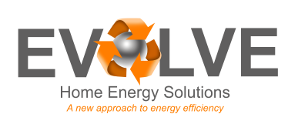
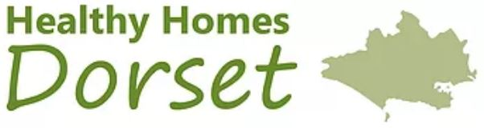
Healthy Homes Dorset – Parish newsletters

Warming up Dorset!
Do you struggle to keep your home warm or worry how you will afford your energy bills this winter?
Contact Healthy Homes Dorset for free, impartial advice about keeping your home warm, using your heating system, understanding your energy bills and making energy saving improvements – if you’re eligible for loft or cavity wall insulation it will be free! We will also register you for power cut support, a handy service to be on if you experience a power cut in your area. Our advice can be given through home visits as well as over the phone. Fire safety alarm and appliance checks can also be organised in partnership with Fire and Rescue for eligible residents.
If you, or someone you know, would benefit from speaking to a trained energy advisor, then get in touch.
Call 0300 003 7023
email help@healthyhomesdorset.org.uk
Web www.healthyhomesdorset.org.uk
Healthy Homes Dorset is a service provided by Dorset County Council, funded by Public Health Dorset and managed by the Centre for Sustainable Energy in partnership with Evolve Home Energy Solutions.

